Q1)

1. Below you may see the screenshots of the ping command results. The one in black color was taken at midnight and the white one was taken at noon.





As we may see in the last line of the result of the ping command, the average round trip delay at midnight is calculated as 153.833 ms and the 328.182 ms at noon. Regarding network connectivity, this indicates that the connectivity at noon is slower than the connectivity at midnight. This means that the network traffic at noon is high compared to midnight, which leads the average RTT to increase. This is because more people are likely to use the internet during the day than midnight and this increased traffic is causing more delays during noon.

1. Below you may see the screenshots of the traceroute command results. The one in black color was taken at midnight and the white one was taken at noon.





From the output of the traceroute command we can see that the network topology from Istanbul to Purdue University involves different paths and routers. The traceroute command shows the number of routers the data packages travel to reach our specified destination point which is [www.purdue.edu](http://www.purdue.edu). Looking at the results we may see that the paths taken by the packages differs; for example, at the 16th router it is observed that at noon the path is from ve114.core2.par2.he.net and at midnight

It passes from another router. The fact that the path the packages travel to reach the destination indicates that there may be potential bottlenecks in the network during the peak hours. Bottleneck happen when too much data enters one source and causes the flow in that source to slow down or become unresponsive to the flow. For example, if large amount of people try to reach the same website we may encounter bottleneck causing the some users to encounter error and essentially not reach that website. In our example we have observed that average RTT is higher at noon so we may say that having potential bottlenecks are more likely at noon than midnight because the network traffic seems to be more. Accordingly, the likelihood of possible bottlenecks at midnight is low.

1. The number of routers at noon was 26 and the number of routers at midnight was 24. The path used at noon is different than the path used at midnight and this could be due to the amount of network traffic. As discussed in the lectures if a router has too much packages waiting to be transferred than the path of the newly send packages may be rearranged so that the transfer would be more efficient in terms of time spend transferring the packages. For example the packages can go through the routers located in X region of Earth at one hour of the day and at another hour they may choose to travel through the routers located in Y region of the Earth depending on the network traffic.

Q2)

1. Calculated using Google Maps Total Air distance from my location to Purdue University is 8897.41 km (you may see the image below regarding the distance).

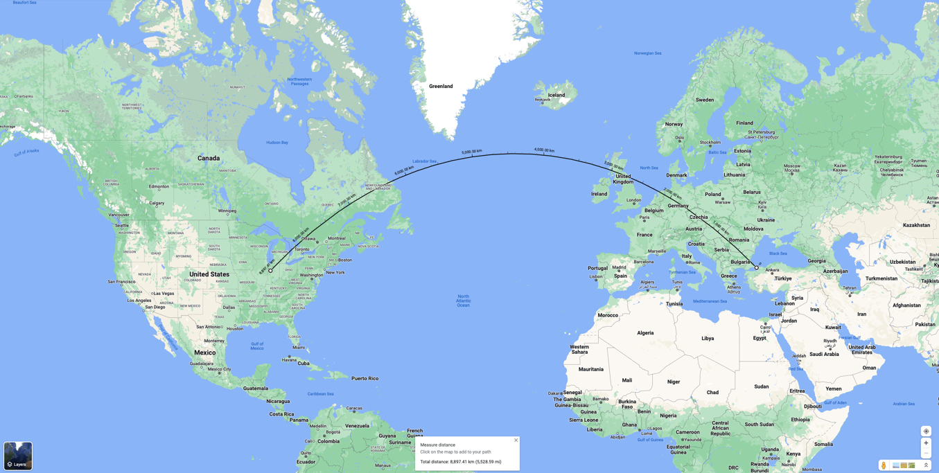

Propagation delay is the time it takes a bit to propagate from one router to the next. Propagation delay is calculated as the following *dprop = d/s* d is the length of the physical link in meters and s is the propagation speed which is the speed of light in m/s.

*dprop = (8897410) / (2x10 8) = 0.04448705 s = 44.48705 ms*

1. I have calculated the approximate fiber optic cable distance from Istanbul to Purdue using Google Maps. My calculation steps were as follows:

* The distance from Istanbul to Marmaris: 463,71 km = 463710 m
* Distance from Marmaris to GoonHilly Downs, UK: 3678,82 km = 3678820 m
* Distance from GoonHilly Downs, UK to NY, USA: 5847,57 km = 5847570 m
* Distance from NY, USA to Purdue: 1089,12 km = 1089120 m

In total the approximate distance of the fiber optic cable that follows the specified path is: 11.079.220 m

The propagation delay for this distance would be as follows:

*dprop = (11079220) / (2x10 8) = 0.* *0553961 s = 55.3961 ms*

As discussed in the lectures, RTT (Total Round Trip Time/Delay) is the total delay + the time needed for the acknowledgement to be received by the sender. We have calculated the propagation delay above. By using this value, we can calculate the RTT. The packet has to travel the distance twice; once for the packet itself and once for the acknowledgement so RTT can be calculated as twice the propagation delay.

*RTT = 2 x dprop : 2 x (55.3961) = 110.7922 ms*

1. In Q1 a) we have calculated the average RTT as 153.833 ms at midnight and the 328.182 ms at noon, however in Q2 b) we have calculated the average RTT value as 110.7922 ms so they are different from each other. The reason for that difference may the following; as we have seen with the results of the ping command at two different hours of the day the packages can take different routes just like in the packet switching example there are no fixed paths and packets are routed according to the best path available at the time. The results that we have seen in Q1 and the paths that are followed are decided according to the network traffic at that time however the paths and results that we see in Q3 are fixed. Also, another factor may be that in the calculations of Q3 we take the speed of the transfer to be constant, however in real life there may be parameters that are affecting the speed of the transfer. Lastly the result of Q1 can be affected by the routers, if one router is overloaded or simply not functioning well it may cause delay which will also cause the RTT values to be different.

CS408 HW1 – Zeynep Kurtulus

29045